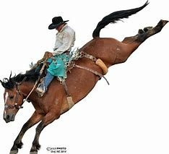

$____________ ***The Tri State Rodeo Association*** will include sponsor name on the event saddle for a donation of $1000. It includes sponsorship name on our web page for a year and displayed on the finals jacket as well as on the saddle. Two tickets for the performances at the finals are provided.

____________________________________

Event Sponsored

________________________________________________________________

Sponsorship name and address

________________________________________________________________

$____________ ***The Tri State Rodeo Association*** will accept a donation for the sponsorship of a belt buckle for the year end $125. or

$____________ Chute sponsorship $500

It will include a sponsorship name on our web page. Two Tickets for the performances at the finals are provided.

____________________________________

Event Sponsored

_________________________________________________________________

Sponsorship name and address

_________________________________________________________________

________________________________________________ and the *Tri State Rodeo Association* agree:

*To cooperate in the above-mention promotion as it is stated in this document. However, if either party is unable to render any of its responsibilities as described by reason of war, strike, act of God or any other circumstances beyond its reasonable control, the other party shall hold the party unable to perform its full responsibilities harmless from any and all damages or loss of any kind.*

______________________________________ ____________________________________

*Sponsor Signature* *Tri State Rodeo Association/Director*

*Date:* _________________________________ *Date:*  _______________________________